**Utility to change one level of an account number to different number.**

**\*\*\*\*\*This utility cannot be run if there are any postings to the general ledger**.  **\*\*\*\*\*\***

1. Go to Network Administration
2. Go to Run Custom Procedure
3. Type in **Util/findreplaceaccnum.r** and click run

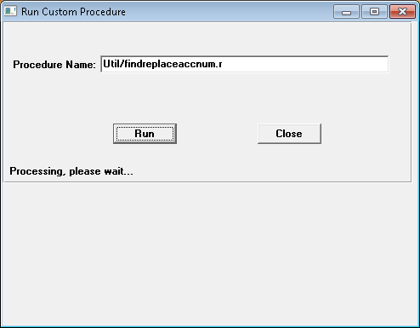

1. The screen below will pop up. Fill in the fields as needed.

This utility cannot be run if there are any postings to the general ledger.

**Company** - The company code you are replacing account numbers for

**Level to Change** - The Level of the account number that you are changing

**Find** - Number you are overriding in the F

**Replace With** – The number you are replacing the account number with

